Programming Assignment Week 3

**Q1**

the code’s explanation is inside the code, the code was commented in order to make it more understandable

**SCRIPT SCREENSHOT:**

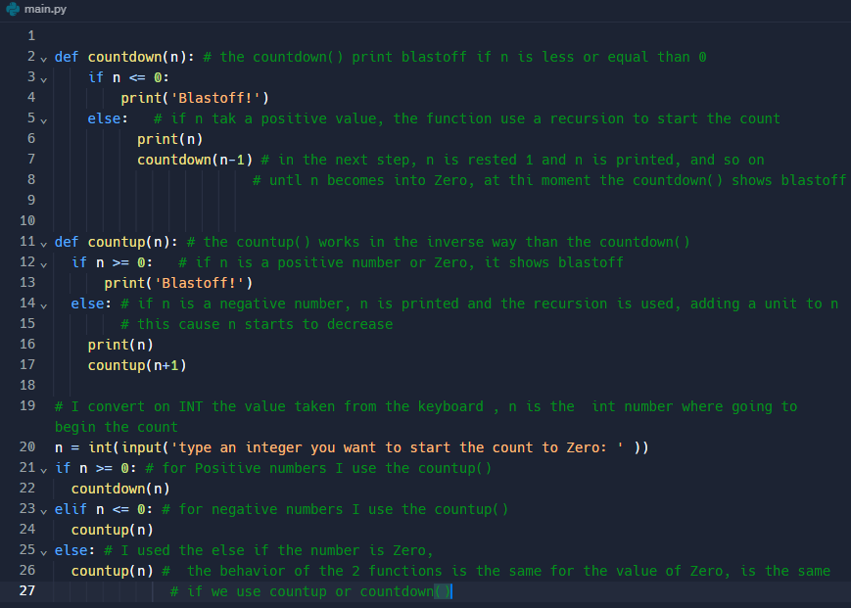

**OUTPUT**

Entering a positive number, in this case, enter the number 10

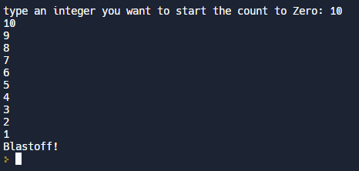

Entering a negative number, in this case, enter the number -8

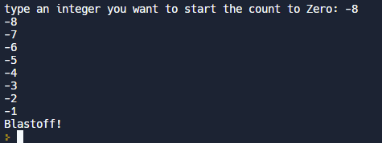

Entering the number Zero (0)



**CODE:**

def countdown(n): # the countdown() print blastoff if n is less or equal than 0

if n <= 0:

print('Blastoff!')

else: # if n takes a positive value, the function uses a recursion to start the count

print(n)

countdown(n-1) # in the next step, n is rested 1 and n is printed, and so on

# untl n becomes into Zero, at this moment the countdown() shows blastoff

def countup(n): # the countup() works in the inverse way than the countdown()

if n >= 0: # if n is a positive number or Zero, it shows blastoff

print('Blastoff!')

else: # if n is a negative number, n is printed and the recursion is used, adding a unit to n

# This causes n start to decrease

print(n)

countup(n+1)

# I convert on INT the value taken from the keyboard, n is the int number where going to begin the count

n = int(input('type an integer you want to start the count to Zero: ' ))

if n >= 0: # for Positive numbers I use the countup()

countdown(n)

elif n <= 0: # for negative numbers I use the countup()

countup(n)

else: # I used the else if the number is Zero,

countup(n) # the behavior of the 2 functions is the same for the value of Zero, is the same

# If we use countup or countdown()

**Q2**

**def division(a,b):**

**print(round(a/b,2))**

**a =int(input('Please enter the Numerator: '))**

**b =int(input('Please enter the Denominator: '))**

**division(a,b)**

**'''**

**def division(a,b):**

**if b == 0:**

**ZeroDivisionError**

**else:**

**print(round(a/b,2))**

**a =int(input('Please enter the Numerator: '))**

**b =int(input('Please enter the Denominator: '))**

**division(a,b)**